NAME: DIPANSHU SHARMA 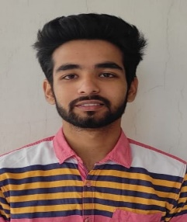

ADDRESS: H NO. 32 A GALI NO. A –MAIN

ASHOK VIHAR PHASE 3 - EXTENSION GURUGRAM

EMAIL ID: [dipanshusharma1538@gmail.com](mailto:dipanshusharma1538@gmail.com)

Contact no.:9871647140

CAREER OBJECTIVE

**To be a part of an enthusiastic work environment , where I can use my technical skill to accomplish organizational goals.**

**ACADEMIC BACKGROUND**

|  |  |  |  |
| --- | --- | --- | --- |
| **INSTITUE/UNIVERSITY** | **DEGREE/EXAMINATION** | **PERCENTAGE** | **YEAR** |
| **Dronachary College Of Engineering,Gurugram** | **B.TECH** | **PURSUING (1ST YEAR)** | **2021-2025** |
| **SCR Public school,Gurugram** | **12th** | **91.1%** | **2021** |
| **Gyan Devi School,Gurugram** | **10th** | **87.2%** | **2019** |

**TECHNICAL SKILLS**

**\*Language : basic concepts of C, c++,java.**

**\*Operating systems: Microsoft windows ,XP/VISTA, Windows 10.**

**CERTIFICATION AND WORKSHOPS ATTENDED**

**\*Certification of C from coursera in June 2022 .**

**\*Certificate of spoken tutorial.**

**\*Participated in NCAT.**

**\*Attended two days workshops on web development .**

**STRENGTHS**

**\*The ability to work in a team .**

**\*Finding the solution calmly.**